# 

The Spirit of the Lord GOD is upon me; because the LORD hath anointed me to preach good tidings unto the meek; he hath sent me to bind up the brokenhearted, to proclaim liberty to the captives, and the opening of the prison to them that are bound; (Isa 61:1)

Liberty Behind Bars

|  |  |  |
| --- | --- | --- |
| **Dale Morey** | **3//2016** | **Black Creek Baptist Church** |

W

e apologize for not getting an updated newsletter out sooner. There was a “famine” at the Allegany County jail for approximately 3 or 4 months. None of the inmates were “calling” out for religious services – whether on my scheduled week or not. I emailed the sergeant about two weeks ago with my concerns. It was on March 19th, the Sunday after I emailed, that over 14 inmates (both male and female) wanted church services. Both Pastor Cacciola (pastor at Anchor Baptist; Wellsville) and I both felt that hearts were touched. This week over 20 inmates were at our services! Praise the Lord! In the last 2 weeks I have sent out over 14 King James Bibles to various inmates as well!

Last week I did receive an email from the Sergeant. She said that the inmates were so excited about the services and she was happy that things went well. This is the first time I have had any feedback from the jail. The Lord is moving!

College is going well and I only have a few more courses to take and I will have completed my Master’s degree in Christian Counseling. I am looking forward to continuing in the Doctoral program as well. We are praying the Lord supply the finances for this endeavor as it is much cheaper to pay the whole thing up front than to make monthly payments.

**Praises**

W

e had the opportunity to work with a printing company in Pennsylvania and found King James Version French bibles. There were a few inmates at the jail that requested a French bible. I wanted to make sure that I found the correct version in that language before I sent it to them. The printing company sent the bibles directly to a few French inmates at the jail at a discounted price. When I saw the inmates this past week – all three were using the bibles. They were very thankful for them.

**Prayer Requests**

W

e are in the process of filing for a 501(c) (3). Being "501(c)(3)" means that a particular nonprofit organization has been approved by the Internal Revenue Service as a tax-exempt, charitable organization. "Charitable" is broadly defined - being a religious ministry falls under that category. One of the primary benefits of being tax-exempt under IRC Section 501(c)(3) is the ability to accept contributions and donations that are tax-deductible to the donor. However, applying for this status will cost anywhere between $250-$450. Please pray that the Lord provide for this fee, as we want to make sure that we are doing everything with this ministry the proper way.

**Specific Needs:**

* stamps
* 9x12 envelopes (to send bibles to inmates)
* regular legal size envelopes (sending monthly “message in the mail” to inmates)
* printing paper
* King James Bibles

If anyone would like to make a donation to Liberty Behind Bars (financially), please make checks payable to Black Creek Baptist Church c/o Liberty Behind Bars (in memo part of the check).

Continue to pray for the safety and salvation of the inmates and guards, and their families. Keep our family in prayer for spiritual, physical and financial needs.

*Now no chastening for the present seemeth to be joyous, but grievous: nevertheless afterward it yieldeth the peaceable fruit of righteousness unto them which are exercised thereby. (Heb 12:6-11)*

Please pray that the Lord opens doors in other area jails and prisons that I may come in. Also, the doors are open to other churches in which I can present this ministry.

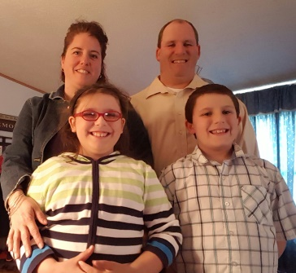

Many blessing to you all!

Again thank you for all of your prayers!

Your servant in Christ

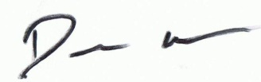

Amy, Dale, Autumn, and Luke

**Thank you for your support and prayers!**