# 

The Spirit of the Lord GOD is upon me; because the LORD hath anointed me to preach good tidings unto the meek; he hath sent me to bind up the brokenhearted, to proclaim liberty to the captives, and the opening of the prison to them that are bound; (Isa 61:1)

Liberty Behind Bars

|  |  |  |
| --- | --- | --- |
| **Dale Morey** | **6/19/2016** | **Black Creek Baptist Church** |

I

have been faithfully going to the Belmont Allegany Jail for the last 6 weeks. During these visits I have seen some inmates transferred to new facilities, some released, and other new inmates arrive. Although it is nice to see some of these inmates are released, it also is difficult to know that it may have been the only time the true gospel will be heard by them.

At the beginning of June, we received our first church support and look forward to other churches to not only financially assist in the ministry but also be prayer warriors for Liberty Behind Bars. I have sent out 7 contact packages to various jails and prisons in the area. We are hoping that we will be able to start going to these facilities and reach out to those behind bars. We did receive notice from one jail that they appreciate what our ministry does, but currently do not have an opening for us to come in.

**Praises**

W

e’ve had many blessings as our ministry grows. Knowing our church family and others praying for us has been so important to us. I did receive an email from one of the sergeants at the Allegany County Jail that she is trying to get approval for me to come on a separate day during the week (on a weekly basis) to meet with the inmates. Please continue to pray that this door opens.

**Prayer Requests**

W

e are asking prayer that the Lord keeps the door open so I can go into the jail every week. I did hit a roadblock in that a church was upset that I showed up one Sunday, when it was their “appointed” day to come in. Although for the past 7 weeks I have gone and no other church has shown, this particular time this church did and felt that I should have been allowed to go in. It is hard to know whether churches will be there or not – thus I go every week hoping the Lord allows me in.

Unfortunately my family was in a car accident, but Praise God that no one was injured. Although it was deemed that we were not at fault for the accident, there is a dispute with the insurance company and are imputing a large deductible be paid for the extensive work that needs to be done. Please pray that this can be resolved. This has been one test among many this month and we continue to look to the Lord for strength and guidance during these tribulations.

Continue to pray for the salvation of the inmates and guards. Also, that the program director allows me to come on a weekly basis on different day of the week. College is going well, but continue to pray because there is a lot of material to know.

*Now no chastening for the present seemeth to be joyous, but grievous: nevertheless afterward it yieldeth the peaceable fruit of righteousness unto them which are exercised thereby. (Heb 12:6-11)*

I am scheduled to have back surgery on July 20th (Amy’s birthday no less…). Please, please pray that this surgery will be successful and for a quick recovery. I will be out of work for 3 months, so please pray that the Lord provides our “daily bread.”

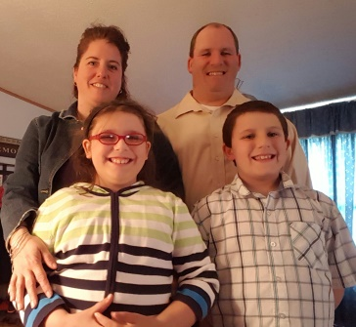Again thank you for all of your prayers!

Your servant in Christ

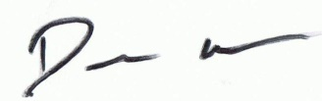

Amy, Dale, Autumn, and Luke

**Thank you for praying!**